**The below output shows User Home Page. User can login with user credentials**

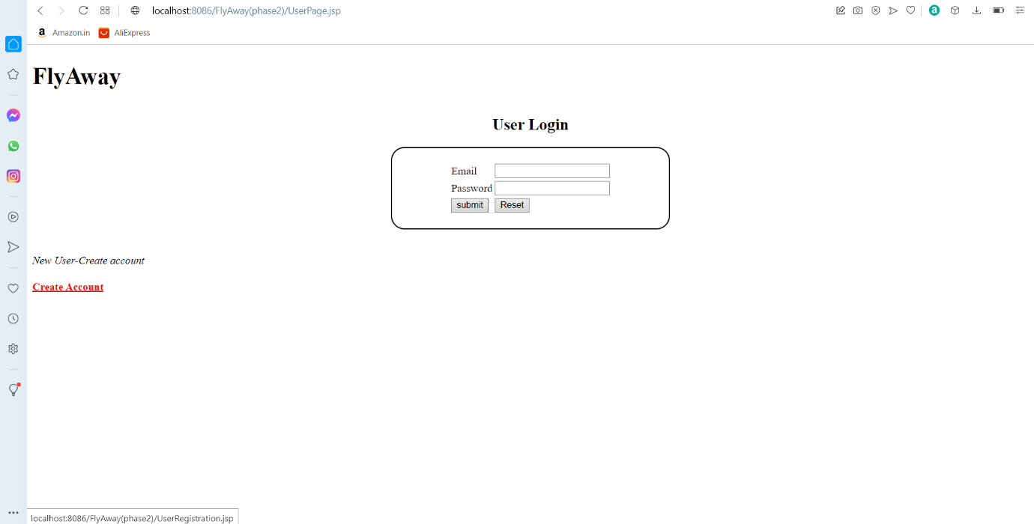

**The below output shows User Registration. Here New User can create their Account and login with the credentials**.

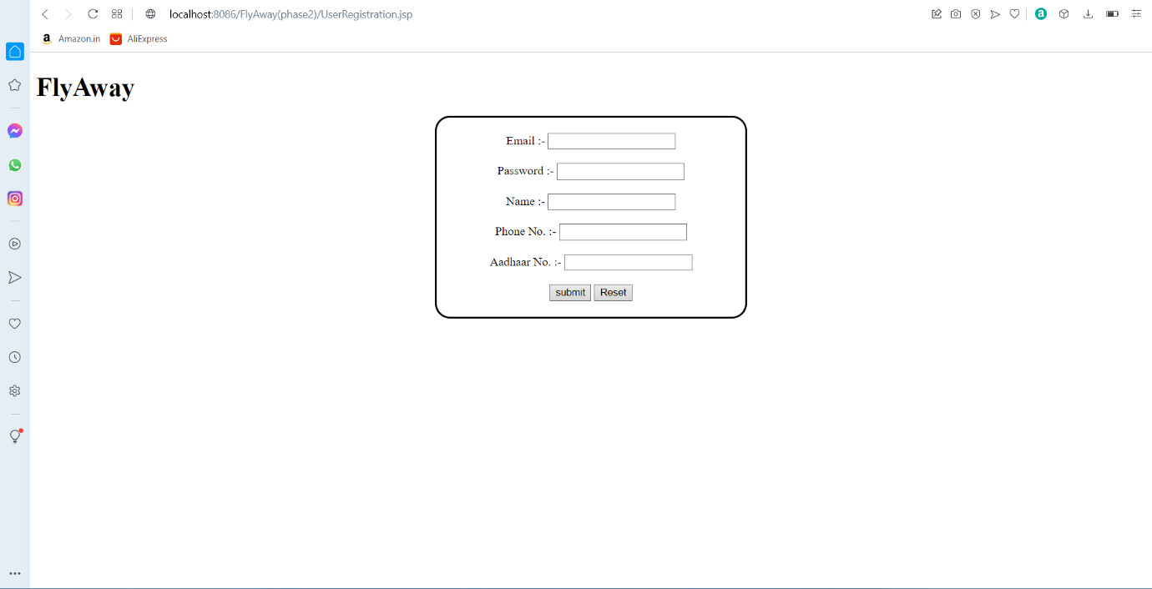

**The below output shows Home Page of Fly Away. Here user can search Flights.**

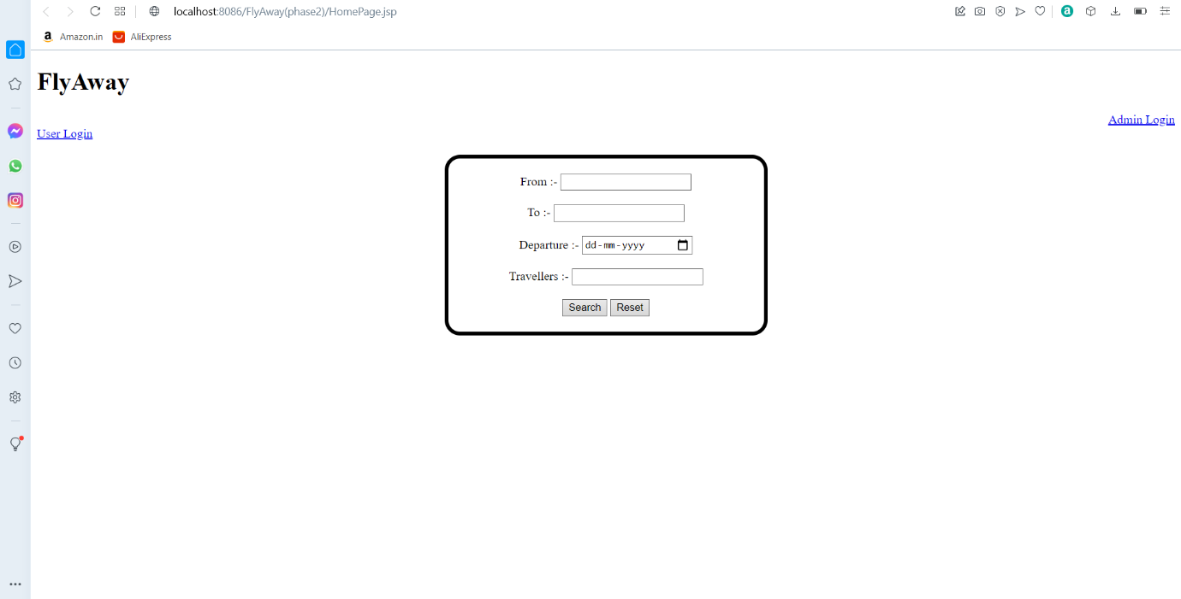

**The below output shows Flight List. If user wants to flight, he can Book the flight**.

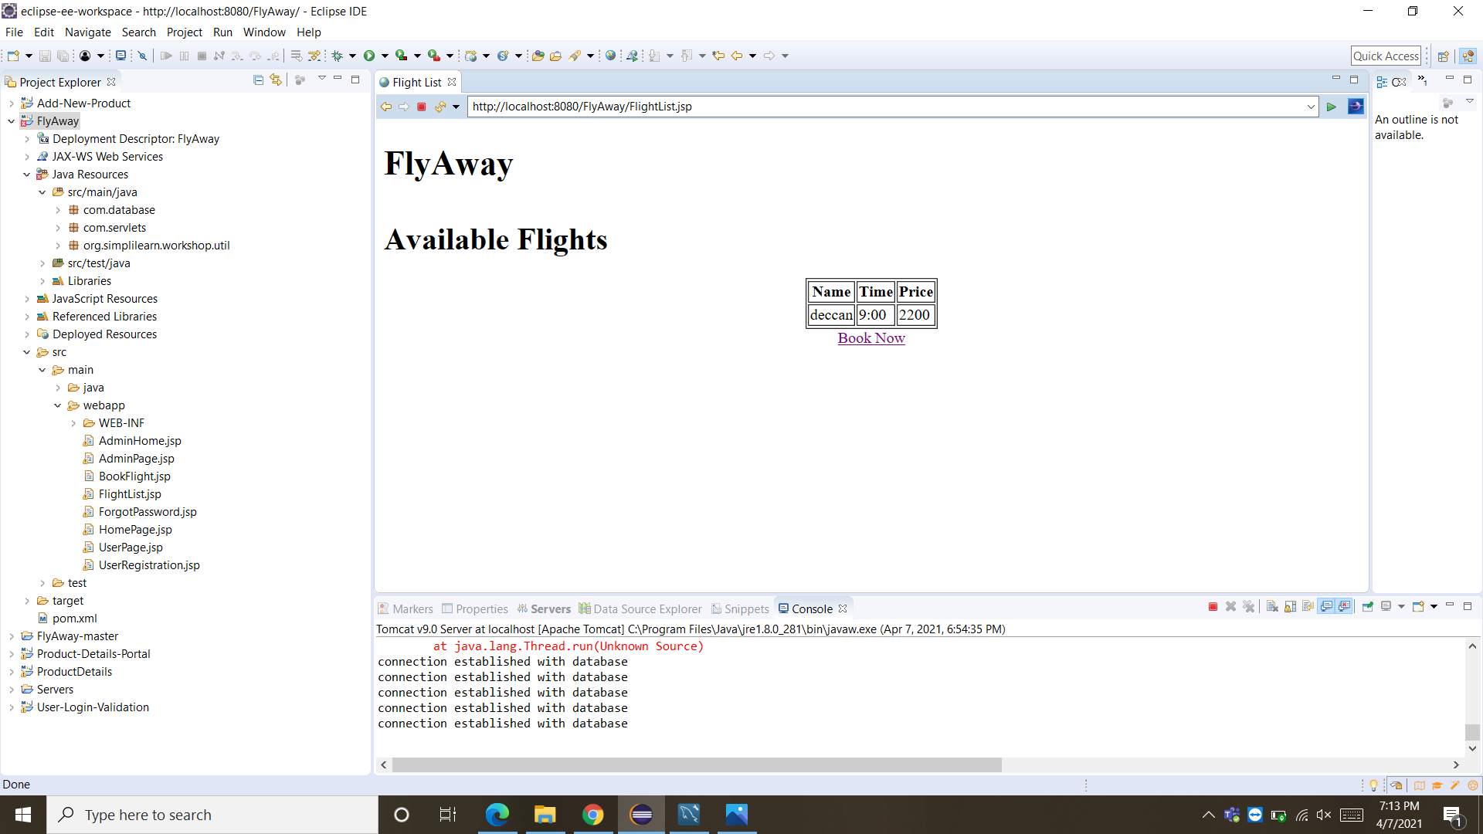

**The below output shows Flight Booked Successfully.**

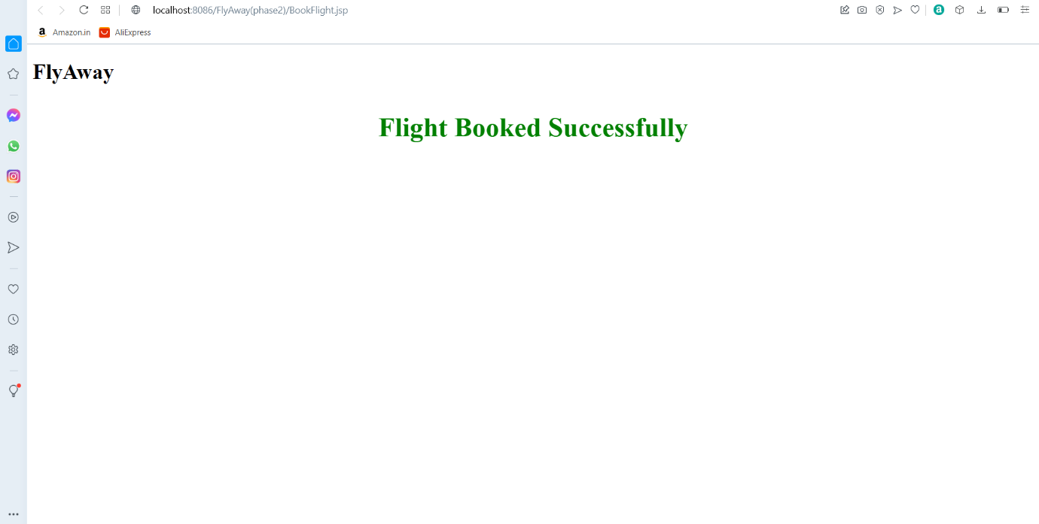

**The below output shows Admin Login page.**

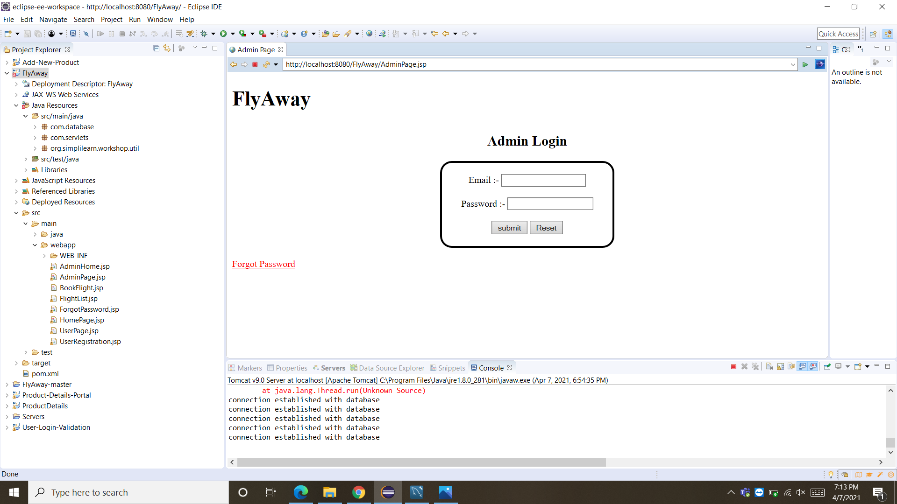

**The below output shows if the, Admin forgot his password, he can use forgot Password and he can create new password.**

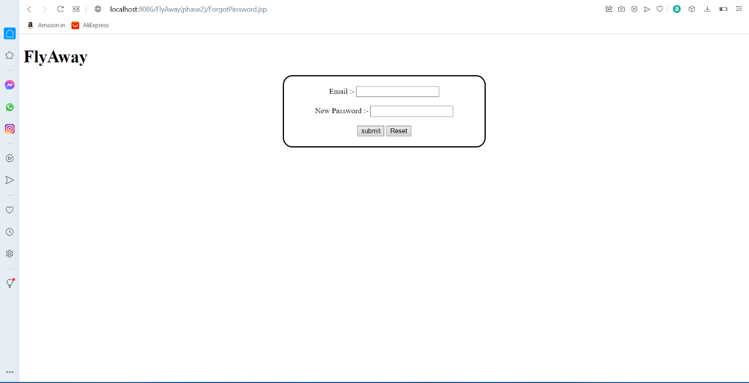

**The below output shows Insert New Flight Details.**

